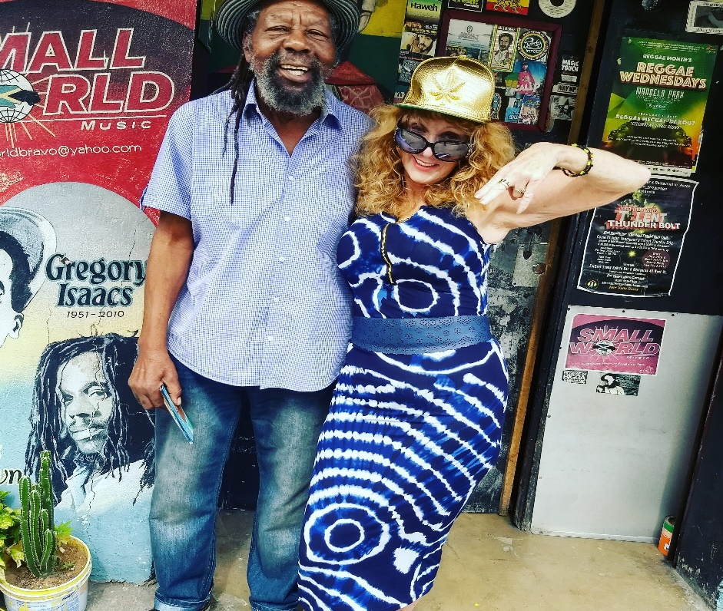

Sista Sensi has lived and performed in Jamaica for over 40 years. She has shared stages and recorded with the toppa top of reggae super-stars including King Yellowman, Daddy URoy, Big Youth, Cutty Ranks, Josey Wales and countless more. Sensi learned to chat Patwah and sing reggae while imprisoned in Jamaica, first at the notorious “14” Barnett St. in MoBay and finally at “GP”, General Penitentiary in ’75 for possession of ganja. She adopted her name in defiance of this and is a fierce proponent of legalisation of herb. She wrote her song “14” about this experience. A regular on the music scene in Negril, Kingston and Montego Bay, Sensi is well-known in Jamaica and her songs are played internationally. She tours the US in summers and winters in Yaad.

